Ex.No.-1.2-Design and Draft the given 2D Sketches in modelling software

AIM :

To sketch the given drawing with dimensions using fusion 360 tool.

REQUIREMENTS:

- Autodesk fusion 360
- Windows 10
- 16 GBof RAM (integrated graphics recommend 1GB or more)
- 2.5 Mbps or faster download; 500 Kbps or faster upload

PROCEDURE:

- Click Create Sketch and select the XY Plane (front or top plane).
- Place the Origin (0,0) precisely at the center of the component.
- Draw a center-diameter circle at the origin with a radius of 16mm (Diameter: 32mm).
- Draw two more concentric circles at the origin with radii of 32mm (Diameter: 64mm) and 40mm (Diameter: 80mm).
- Draw lines parallel to the vertical and horizontal axes, offset by 3mm on each side to create the 6mm structural ribs.
- Draw a circle at coordinates X=50, Y=60
with a radius of 15mm (Diameter: 30mm).
- Draw its outer concentric lobe circle with a radius of 21mm (Diameter: 42mm).
- Draw a circle at coordinates X=70, Y=0 with a radius of 15mm (Diameter: 30mm)
- Draw its outer concentric lobe circle with a radius of 20mm (Diameter: 40mm).
- Repeat the top lobe process at coordinates X=50, Y=-60
- Use the 3-Point Arc tool to create the outer transitions (R20) between the lobes and the center hub (R40).
- Apply the Tangent Constraint between all connecting arcs and outer lobe circles to ensure smooth transitions.
- Select all sketched outer lobes and arcs, click the Mirror tool, and use the Vertical Axis (Y-axis) as the mirror line to generate the left side perfectly.
- Use the Trim Tool (T) to cut away the internal intersecting lines within the 6mm ribs and the outer profile loops until you have distinct closed profiles.
- Click Finish Sketch, press E (Extrude), select the solid face profiles (avoiding the holes and slots), and extrude to your required plate thickness.

OUTPUT:
SKETCH:
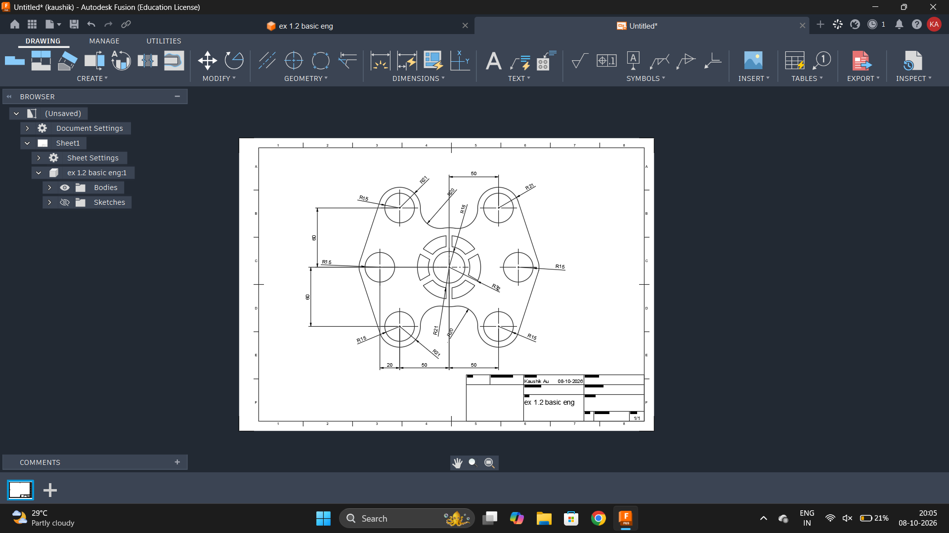

RESULT:

Thus the given sketch is drawn and drafted using fusion 360 tool.

